Aggregator scripts: how to use them
26/1/2026
Chris Jacobs-Crisioni, Bureau Jacobs-Crisioni

Introduction
The aggregator configuration is set up for rapid mass aggregation of grids with variables to predefined boundaries. In the reference application, these boundaries are spatially mutually exclusive sets of FRAs and FUAs. The configuration is set up with predefined FRAs and FUAs (the _x1 release from January 22, 2026) and weights (Ardeco-adjusted 2021 population grids). These inputs can be replaced through parameters.
This file accompanies the aggregator configuration developed for recent GeoDMS versions. Besides this file, the configuration consists of:
- A small program (aggregator.dms) by which data can be aggregated to boundaries.
- Base data currently used for aggregation (FRA and FUA boundaries in data/boundaries/fras_fuas__x1.*** , and population used for weighting in aggregation.
- An input csv file (variables_list.csv) in which target variables, a source path, the wanted aggregation method and weighting 0/1 need to be indicated.

Installation
The aggregator needs a recent version of GeoDMS. The code has been tested and is functional with versions 15.7.1 and 18.1.2, presumably it works with any version released since 15.7.1.
To install and setup GeoDMS, please follow instructions through the GeoDMS academy: https://github.com/ObjectVision/GeoDMS_Academy/wiki/Module-0%2C-Install-GeoDMS-GUI-and-setup-a-configuration
After installing GeoDMS, unzip the files in a convenient folder on a physical drive. For instance, the author’s version is installed under D:\ProjDir\Aggregator.
Open the configuration through GeoDMS: File > Open Configuration > [path]\aggregator.dms
If successful, the screen should look something like the picture below:
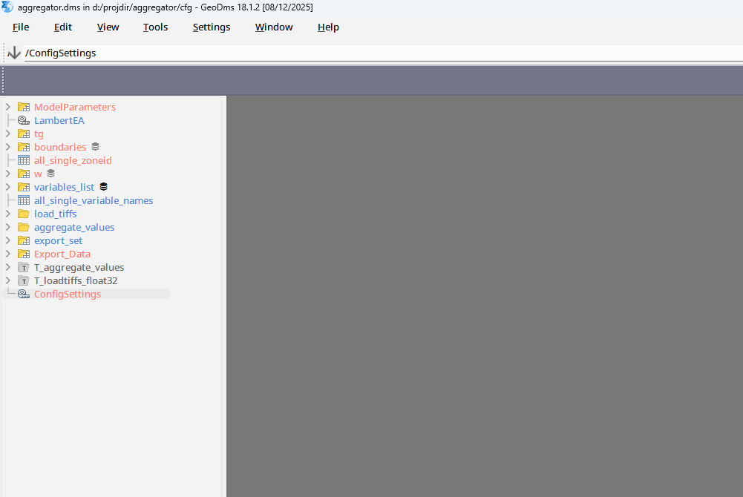

Elements
Elements in the program are:
- ModelParameters: hardcoded references to the main input files (boundaries, weights, variable list)
- Boundaries: loading of the boundaries file (FRAs and FUAs, version x1, by default)
- W: Weight (Ardeco adjusted population in 2021 by default)
- Variables list: csv file containing all the wanted variables and aggregation rules
- Load_tiffs: procedures to load all input grid variables (internal coding)
- Aggregate_values: procedures to aggregate values from load_tiffs
- Export_set: a representation of the values in Boundaries, and all the aggregated values
- Export_data: routine to export the full export_set to a csv file.

Adjusting and running
To add or remove variables, use Excel or a text editor to edit the csv file (in the root project folder, e.g. D:\ProjDir\Aggregator\variables_list.csv on the author’s PC). Every variable is defined on a new line. The fields in the csv file are:
variable_name: contains a unique name used for internal referencing and in the export. Best to avoid special character.
full_path: contains the full path to the grid data used to create the variable. Paths need to have forward slashes, not backwards! These paths may be redundant (in case of multiple variables using the same base grid, the grid is loaded only once).
aggregation_method: the method by which data are aggregated to the larger units (see table below).
weight: 0/1 variable indicating whether the variable needs to be weighted when aggregating. Only one weight is available per run.
To add a variable, simply add a line and fill the four fields for that variable. The inputs are NOT case sensitive. Options for aggregation are given in the table below:
Method | Code | Aliases | Weighting?
Summing total values to larger unit | sum | None | No
Averaging values in larger unit | mean | Average, arith_mean | Yes
Harmonic mean values in larger unit | harm | Harm_mean | Yes
…

After adding the variable, store the csv file. RELOAD THE CONFIGURATION in GeoDMS (e.g. through ALT+R, else File > Reopen the Configuration). The variable is now added to the list.
To store the wanted output file, double click /Export_Data/result. The new aggregated file is then processed and stored in the Store folder of the project directory; e.g. on the author’s computer, D:\ProjDir\Aggregator\Store\Variables.csv.

Input requirements
References to boundaries, weights and the variable lists are hardcoded in the ModelParameters container. In addition, reference to the field by which boundary features are identified in the boundary shapefile is also hardcoded. None of these parameters require adjustment when maintaining the original settings.
To ensure that the aggregation does not violate fundamental data assumptions, the program makes two integrity checks:
- The code field by which target boundary features are identified needs to have unique values (e.g., every feature should have its own exclusive code)
- The variable names identified in the variables_list field are adapted so that e.g. special characters are removed. If a variable name starts with a number, an underscore (‘_’) is added in front. After these modifications, variable names need to be unique.

